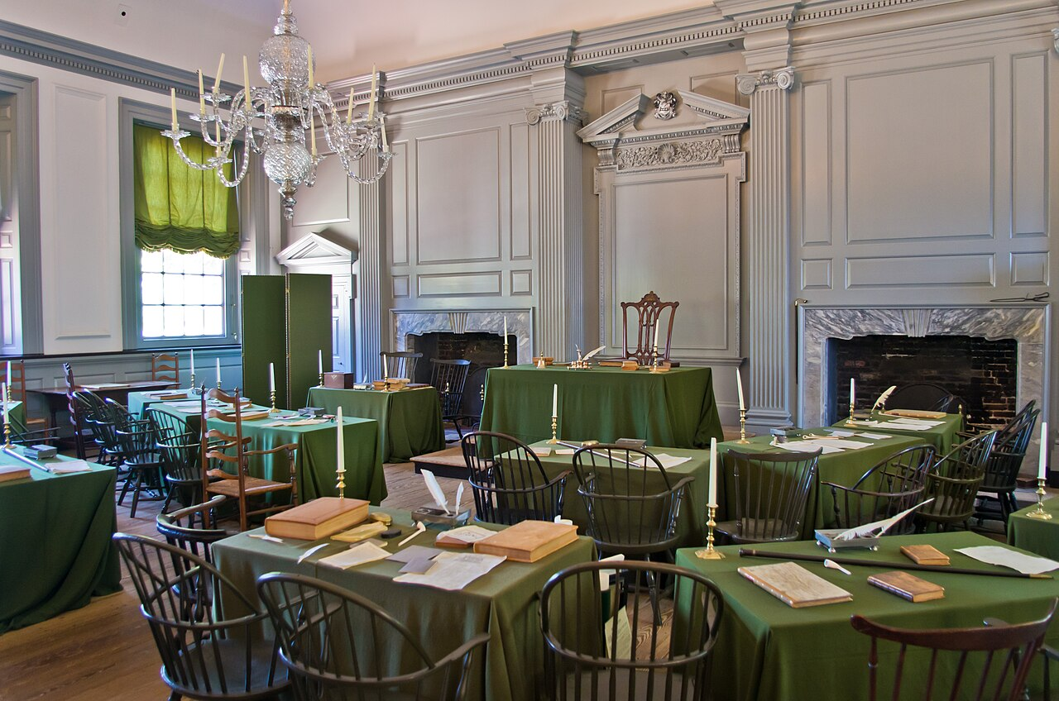
ContitutionTimeline.org
An interactive timeline of the Constitutional Convention
How the Constitution
Came to Be

